Software Design Document
IUB & E Web Portal



Submitted by
Masood Ur Rehman

Roll No
S23BINFT1M01101

Submitted to
Dr. Rizwan Ali Shah

Department of Information Technology
Faculty of Computing
The Islamia University of Bahawalpur

Summary
The IUB & E Web Portal is a web-based academic management system for The Islamia University of Bahawalpur. It provides Student Portal, Teacher Portal and Administration Panel to access and manage academic data online. Student can view his/her personal info, enrolled courses, attendance, results, grades and announcements online. Teacher can add/edit/manage his/her courses, upload attendance, enter marks and post announcements online. Administrator can manage user accounts and courses. The portal is developed using HTML5, CSS3, JavaScript and Bootstrap 5 for Frontend, Laravel (PHP framework) for Backend and MySQL for database. The application is running on local XAMPP server. The system follows MVC architecture for better separation of concerns, security, scalability and maintainability. The portal aims to minimize paper work and manual overhead of the university and to provide a single online platform for all academic management.

Contents
1. Application Architecture 5
1.2 Proposed Models 5
1.3 Proposed Views 6
1.4 Proposed Controllers 6
1.4.1 Authentication Controller 6
1.4.2 Student Controller 7
1.4.3 Teacher Controller 8
1.4.4 Admin Controller 9
1.6 UML Diagrams 11
1.6.1 High-Level Design (HLD) Architecture Diagram 11
1.7 Coding Conventions 14
2. Data Model Schema 15
2.1 Entities 15
2.1.1 User Entity 15
2.1.2 Student Entity 16
2.1.3 Teacher Entity 16
2.1.4 Course Entity 17
2.1.5 Enrollment Entity 17
2.1.6 Attendance Entity 18
2.1.7 Marks Entity 18
2.1.8 Announcement Entity 19
2.1.9 Entity Relationships 20
2.2 Database Constraints 21
2.3 Data Integrity 21
2.4 Future Database Enhancements 22
3. User Interface 23
3.1 User Interface Design Philosophy 23
3.2 Color Scheme 23
3.4 Responsiveness and Screen Constraints 24
3.5 User Interface Screens 25
3.5.1 Landing/Home Page 25
3.5.2 Login Page 26
3.5.3 Student Dashboard Page 27
3.5.4 Teacher Dashboard Page 27
3.5.5 Admin Dashboard Page 28
3.5.6 Course Management Page 29
3.9 Future UI Enhancements 30
4. References 31

1. Application Architecture
The application is designed to follow a modular, decoupled MVC architecture. The frontend section is based on a simple MVC framework that allows students, teachers, and administrators to easily add academic information via a user-friendly web-based interface. The information is displayed clearly for users to view and students can also view their results. The backend section is a full MVC system, built on the Laravel PHP framework and interfaces with the frontend section via REST API. The MySQL database is persistent and strictly relational, holding user information, course details, student attendance, student marks and past academic information. The system uses role-based access control (RBAC). This means students, teachers and administrators can only add/edit/delete information that is relevant to their role within the system.

1.1 MVC Architecture
Component | Purpose
Model | Handles database operations and data validation
View | Shows how content will be displayed to the Student, Teacher and Admin.
Controller | Processes requests and implements business logic

1.2 Proposed Models

The following models represent the core entities of our application.
- User – Represents all system users (students, teachers, admins) with authentication details
- Student – Extends User model with student-specific information
- Teacher – Extends User model with teacher-specific information
- Course – Represents academic courses offered by the institution
- Enrollment – Links students to courses
- Attendance – Tracks student attendance records per course
- Marks – Stores student marks and grades
- Announcement – Contains announcements posted by teachers/admin

1.3 Proposed Views
View | Purpose
Landing Page View | Displays login and registration options on the landing page.
Authentication View | Login and registration forms
Student Dashboard View | Shows enrolled courses, attendance, results and announcements for a student.
Course Details View | Shows detailed information about a specific course
Attendance View | Displays attendance records and percentages
Results & Grades View | Shows semester-wise marks and CGPA.
Teacher Course Management View | Teachers can add courses and upload resources for them.
Attendance Upload View | Teacher interface for marking attendance
Marks Entry View | Teacher interface for entering and updating marks
Announcements View | Display and posting of announcements
Admin User Management View | Interface for adding, editing, deleting users
Admin Course Management View | Interface for managing courses and credit hours

1.4 Proposed Controllers
The Controllers are classes that hold the major logic of a system, i.e. the business logic. Here we handle user input and process it. We use models, to get or to store data of users etc. (in the database) and we return views, to the user, to show him, what has happened to his input Functions.

1.4.1 Authentication Controller
Functions:
- register() – Handles user registration (sign-up) with validation
- login() – Authenticates users and establishes sessions
- logout() – Terminates user sessions
- passwordReset() – Facilitates password recovery via email
- approveRegistration() – Admin approval of pending registrations
Description:
- register() – This controller is used to submit user registration data from the frontend registration form. The function register () is used to validate email address and password, to check if the phone number is composed of 11 digits, and to check if email address and registration/employee ID already exist. If all data is correct, a new user account will be created as a “pending user” that needs to be approved by an administrator. A confirmation email will be sent to the newly registered email address.
- login() – This component logs users into their accounts. It authenticates users using their email and passwords in the database. After a user has been successfully logged in a new session is created for that user and the user is redirected to the appropriate dashboard depending on the role of the user (students, teachers, administrators). This component uses password hashing with the help of bcrypt. It also manages user sessions for logged in users.
- logout() – This function will end user session and direct user to landing page in case he logs out.
- passwordReset() – The controller for the process of password Reset. In this function an email address, generated token and a password reset link is send to a given email address. The email address must exists in the database. Then the user can fill in his/her new password in the given link.
- approveRegistration() – Function for admins to approve pending registration of employees. After clicking on ‘approve’, the status of the user is updated to ‘active’.

1.4.2 Student Controller
Functions:
- viewDashboard() – Display student dashboard with academic summary
- viewEnrolledCourses() – List all courses enrolled in current semester
- viewAttendance() – Show attendance percentage and date-wise records
- viewResults() – Display marks, grades, and CGPA
- viewAnnouncements() – Show announcements from teachers/admin
- updateProfile() – Allow students to edit personal information

Description:
- viewDashboard() – This function is used to fetch information and then display them to the student. This includes student’s name, the program he/she is studying in, the department he/she is studying in and the current semester of the student. This is the starting point for student to view his/her academic information.
- viewEnrolledCourses() – Returns all the courses a student is currently enrolled in for the current semester from the Enrollment table in a format that can be easily viewed by the student.
- viewAttendance() – Calculates and displays attendance percentage for each course and provides date-wise attendance records (present/absent) for the current semester.
- viewResults() – This function fetches marks from the Marks table for a Student. The function then displays the results for a Student for all semesters. For every semester, Student will see his/her individual marks for every subject and also will see the grade he/she got for individual subject. Student will also see his/her CGPA (Cumulative Grade Point Average) for all semesters.
- viewAnnouncements() – Fetches announcements from the Announcement table that are relevant to the student's enrolled courses.
- updateProfile() – Allows students to modify their phone number, address, and profile picture. Validates input and updates the User/Student table.

1.4.3 Teacher Controller
Functions:
- manageCourses() – Update course title, description, and resources
- uploadAttendance() – Mark and upload attendance for a class session
- enterMarks() – Input and update student marks and grades
- postAnnouncements() – Create and send announcements to students
- viewStudentList() – Display list of students enrolled in teacher's courses
Description:
1. manageCourses() – This controller enables teachers to update a course’s details (i.e. title and description) and to upload resources for a course (in the form of documents and hyperlinks). The controller first retrieves all the courses assigned to a teacher, and then allows the teacher to modify the retrieved courses.
2. uploadAttendance() – Attendance for any class session can be marked by teacher for the students of specific course. It takes course id, date of class session and array of students with their attendance status i.e. present/absent. This information is stored in Attendance table and accordingly total attendance and percentage is calculated for student.
3. enterMarks() - The teacher will enter the mid-term, final term and the marks for the student’s assignments. This system will calculate the total marks for the student, and on the basis of the total marks it will provide the grades to the student according to the pre-defined criteria of the system. All the input of the teacher will be validated. No body will be able to change the marks without the permission of admin.
4. postAnnouncements() – This function allows teachers to post announcements to all the students in their classes. The function stores announcements including the date & time when they were created as well as the course to which they are related.
5. viewStudentList() – This function is used by teachers to view the list of all students who are enrolled in all of the teacher’s courses. The list contains the basic information about the student.

1.4.4 Admin Controller
Functions:
- addStudent() – Manually create student accounts
- addTeacher() – Create teacher accounts and assign courses
- addCourse() – Define and create new courses
- deleteUser() – Remove user accounts from the system
- assignCourses() – Assign teachers and students to courses
- viewSystemLogs() – Monitor system activities and user actions
Description:
1. addStudent() – Admin can add a Student record and create an account for that Student by entering Student details (Name, Email address, Registration #, Program, Department) and the system creates an account for that Student immediately with a temporary password generated and an email sent to that Student account.
2. addTeacher() – Admin adds teachers to system and can assign them to courses immediately after creation of their account. Information of teacher is validated before creation of account which is set to active status as soon as account is created.
3. addCourse() – This is to create a new course. Admin will input for the course code, title, credit hours department plus for assign a teacher. All the input will be stored in Course table.
4. deleteUser() - This admin function removes/ deactivates a user and all related data in other tables (i.e. - all marks given by user are removed from database as well as all announcements for user etc - so called cascading delete).
5. assignCourses() – Admin can assign students to courses and teachers to courses. The admin function will create the relationships in the Enrollment table.

1.5 APIs and External Libraries
API/Library | Purpose
Laravel Framework | Backend framework providing MVC structure, routing, middleware, authentication, and ORM (Eloquent)
MySQL Connector | Enables communication between Laravel application and MySQL database
Bootstrap 5 | Frontend CSS framework for responsive design and pre-built UI components
Laravel Blade | Templating engine for rendering views with dynamic content
Eloquent ORM | Object-relational mapping for database operations
Laravel Authentication | Built-in authentication system with password hashing and session management
Laravel Validation | Input validation and error handling
SMTP Service | Email notifications for registration confirmation, password reset, and announcements

1.6 UML Diagrams
The following diagrams explain the working of the system:
- Use Case Diagram – Shows all actors (Student, Teacher, Admin) and their interactions with system functions
- High-Level Design (HLD) Diagram – Displays system architecture and component relationships
- Entity-Relationship (ER) Diagram – Illustrates database schema and table relationships
- Sequence Diagram – Shows interaction flow between components for key operations
- Data Flow Diagram – Demonstrates how data moves through the system

1.6.1 High-Level Design (HLD) Architecture Diagram
This diagram represents the structural development of the project, i.e. how different layers interact with each other:
- Presentation Tier (Frontend) – HTML5, CSS3, JavaScript, Bootstrap 5 running in user's browser. Provides UI for students, teachers, and administrators.
- Web Tier (Laravel Backend) – PHP-based Laravel application server handling authentication, sessions, business logic, and REST API endpoints. Implements role-based access control and request routing.
- Application Tier (Business Logic) – Core Laravel controllers implementing student, teacher, and admin operations including course management, attendance tracking, marks entry, and announcement posting.
- Data Tier (MySQL Database) – Relational MySQL database storing all user data, course information, enrollment records, attendance records, marks, and announcements. Implements ACID compliance and data integrity constraints.
- External Services – SMTP server for email notifications (registration confirmation, password reset links).
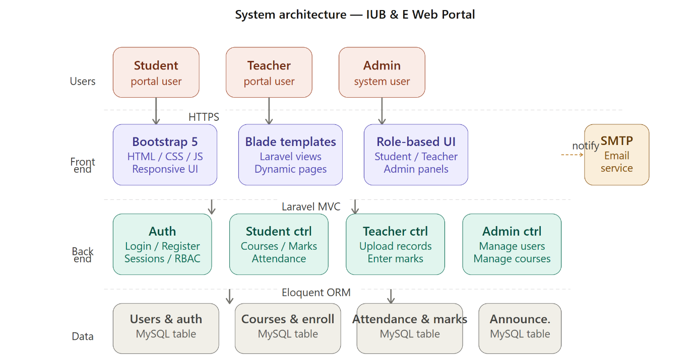



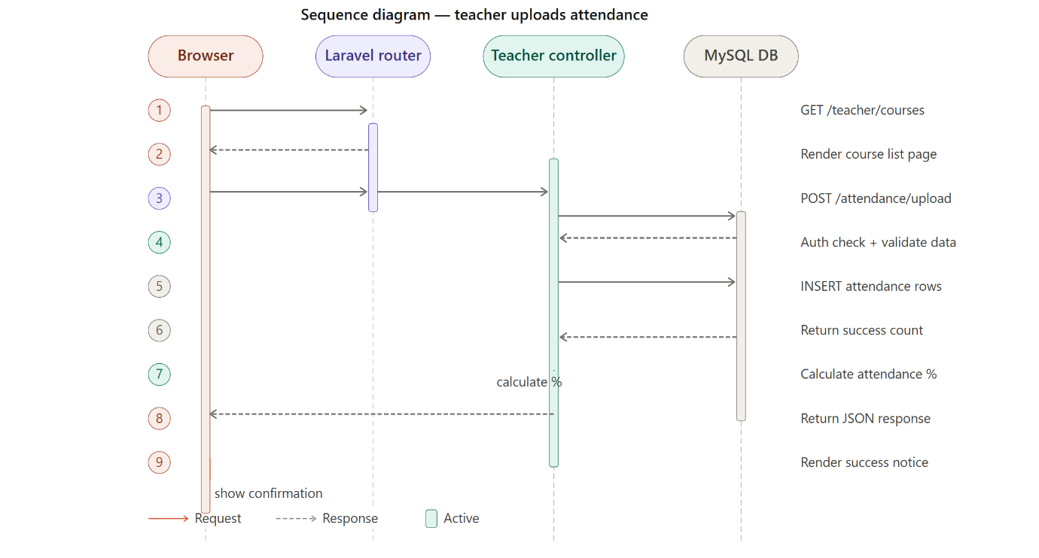

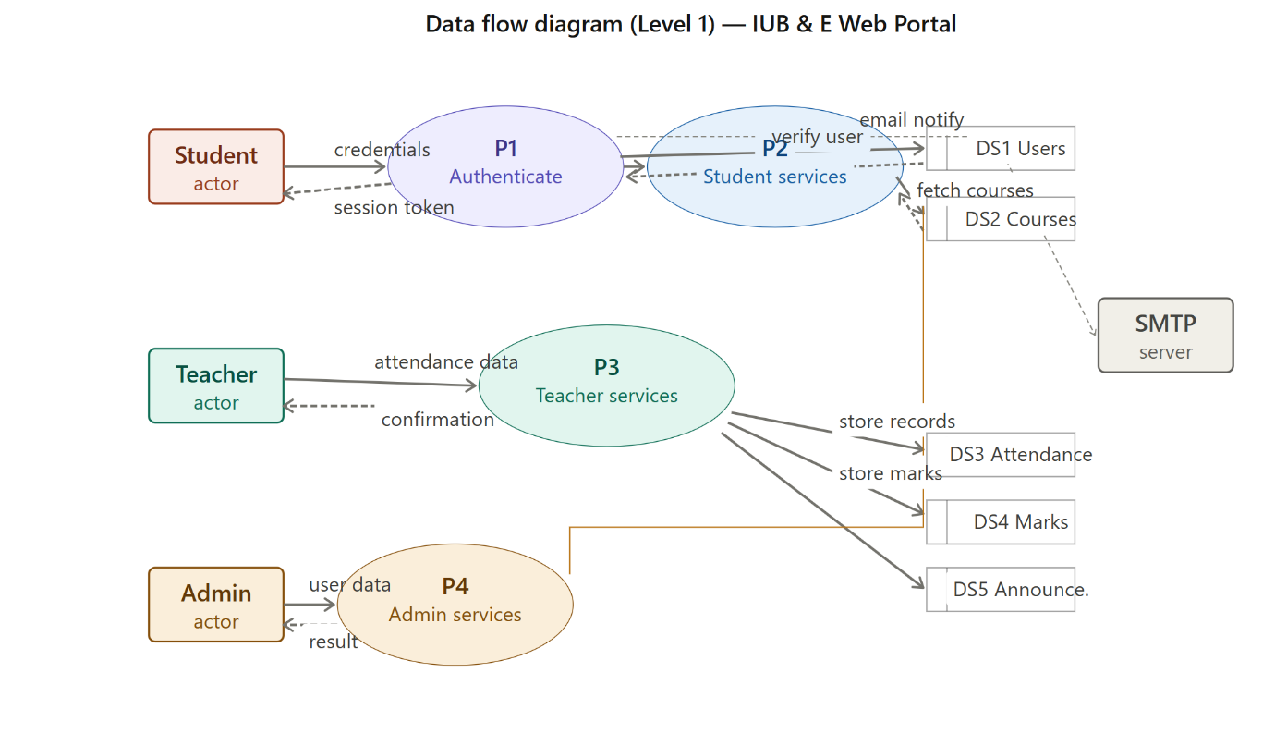

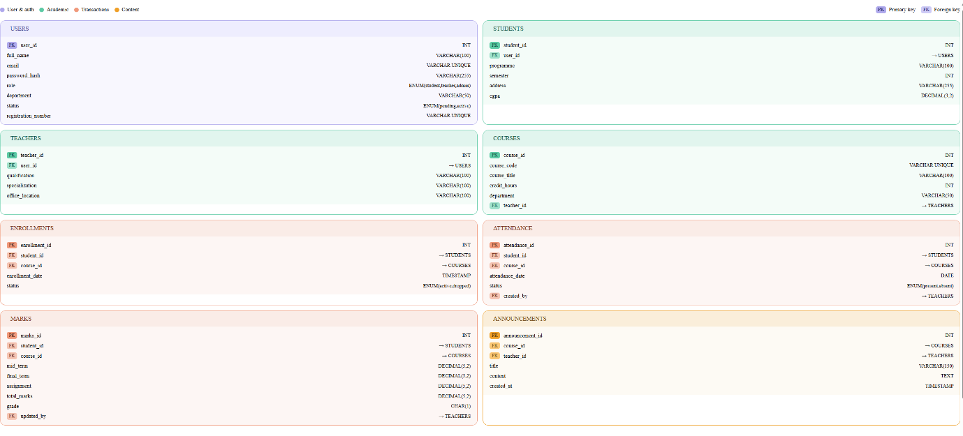

1.7 Coding Conventions
Coding conventions are standards written down for coding so that code is consistent, readable and maintainable. Writing code following coding conventions makes debugging and reading of old code easier.
Element | Convention
Class Names | PascalCase (e.g., UserController, StudentModel)
Function/Method Names | camelCase (e.g., viewDashboard(), addStudent())
Variable Names | snake_case (e.g., user_id, course_name)
Constants | UPPER_CASE (e.g., MAX_STUDENTS, DEFAULT_GRADE)
Database Table Names | plural_snake_case (e.g., users, enrollments, courses)
File Names | PascalCase (e.g., UserController.php, Course.php)

2. Data Model Schema
The IUB & E Web Portal utilizes a relational database schema to store information of users, courses, student enrollments, student attendance, student marks and announcements. MySQL has been chosen as the RDBMS for this system as it is very reliable, easy to implement and is one of the most suited databases for an academic management system.

2.1 Entities
In simple terms, entities represent tables of data in a database and define the data and constraints for a given set of information. The attributes for an entity are the columns in the table for that entity and collectively, the entities, attributes and relationships define the data model or schema for the database for the IUB & E Web Portal.

2.1.1 User Entity
Attribute | Data Type | Constraint | Description
user_id | INT | PRIMARY KEY, AUTO_INCREMENT | Unique user identifier
full_name | VARCHAR(100) | NOT NULL | User's full name
email | VARCHAR(100) | UNIQUE, NOT NULL | Email address for login
password_hash | VARCHAR(255) | NOT NULL | Bcrypt-hashed password
phone | VARCHAR(11) | NOT NULL | Contact phone number
role | ENUM('student', 'teacher','admin') | NOT NULL | User's role in system
department | VARCHAR(50) | NOT NULL | Department affiliation
status | ENUM('pending', 'active', 'inactive') | NOT NULL, DEFAULT 'pending' | Account status
photo_path | VARCHAR(255) | NULL | Path to profile picture
registration_number | VARCHAR(50) | UNIQUE, NOT NULL | University ID or Employee ID
created_at | TIMESTAMP | DEFAULT CURRENT_TIMESTAMP | Account creation time
updated_at | TIMESTAMP | ON UPDATE CURRENT_TIMESTAMP | Last update time

2.1.2 Student Entity
Attribute | Data Type | Constraint | Description
student_id | INT | PRIMARY KEY, AUTO_INCREMENT | Unique student identifier
user_id | INT | FOREIGN KEY (users) | Reference to User table
programme | VARCHAR(100) | NOT NULL | Programme/Degree name
semester | INT | NOT NULL | Current semester
address | VARCHAR(255) | NULL | Student's address
cgpa | DECIMAL(3,2) | DEFAULT 0.00 | Cumulative GPA

2.1.3 Teacher Entity
Attribute | Data Type | Constraint | Description
teacher_id | INT | PRIMARY KEY, AUTO_INCREMENT | Unique teacher identifier
user_id | INT | FOREIGN KEY (users) | Reference to User table
qualification | VARCHAR(100) | NULL | Educational qualification
specialization | VARCHAR(100) | NULL | Area of specialization
office_location | VARCHAR(100) | NULL | Office room/building

2.1.4 Course Entity
Attribute | Data Type | Constraint | Description
course_id | INT | PRIMARY KEY, AUTO_INCREMENT | Unique course identifier
course_code | VARCHAR(10) | UNIQUE, NOT NULL | Course code (e.g., CS101)
course_title | VARCHAR(100) | NOT NULL | Course name
credit_hours | INT | NOT NULL | Credit hours for course
department | VARCHAR(50) | NOT NULL | Offering department
teacher_id | INT | FOREIGN KEY (teachers) | Assigned teacher
description | TEXT | NULL | Course description
resources_path | VARCHAR(255) | NULL | Path to course materials
created_at | TIMESTAMP | DEFAULT CURRENT_TIMESTAMP | Course creation time

2.1.5 Enrollment Entity
Attribute | Data Type | Constraint | Description
enrollment_id | INT | PRIMARY KEY, AUTO_INCREMENT | Unique enrollment identifier
student_id | INT | FOREIGN KEY (students) | Enrolled student
course_id | INT | FOREIGN KEY (courses) | Enrolled course
enrollment_date | TIMESTAMP | DEFAULT CURRENT_TIMESTAMP | Enrollment date
status | ENUM('active','completed','dropped') | DEFAULT 'active' | Enrollment status

2.1.6 Attendance Entity
Attribute | Data Type | Constraint | Description
attendance_id | INT | PRIMARY KEY, AUTO_INCREMENT | Unique attendance record ID
student_id | INT | FOREIGN KEY (students) | Student record
course_id | INT | FOREIGN KEY (courses) | Course reference
attendance_date | DATE | NOT NULL | Date of attendance
status | ENUM('present','absent') | NOT NULL | Attendance status
created_by | INT | FOREIGN KEY (teachers) | Teacher who entered attendance
created_at | TIMESTAMP | DEFAULT CURRENT_TIMESTAMP | Record creation time

2.1.7 Marks Entity
Attribute | Data Type | Constraint | Description
marks_id | INT | PRIMARY KEY, AUTO_INCREMENT | Unique marks record ID
student_id | INT | FOREIGN KEY (students) | Student reference
course_id | INT | FOREIGN KEY (courses) | Course reference
mid_term | DECIMAL(5,2) | NULL | Mid-term marks
final_term | DECIMAL(5,2) | NULL | Final term marks
assignment | DECIMAL(5,2) | NULL | Assignment/project marks
total_marks | DECIMAL(5,2) | NULL | Auto-calculated total marks
grade | CHAR(1) | NULL | Letter grade (A, B, C, D, F)
semester | INT | NOT NULL | Semester number
updated_by | INT | FOREIGN KEY (teachers) | Teacher who entered marks
updated_at | TIMESTAMP | ON UPDATE CURRENT_TIMESTAMP | Last update time

2.1.8 Announcement Entity
Attribute | Data Type | Constraint | Description
announcement_id | INT | PRIMARY KEY, AUTO_INCREMENT | Unique announcement ID
course_id | INT | FOREIGN KEY (courses) | Associated course
teacher_id | INT | FOREIGN KEY (teachers) | Teacher posting announcement
title | VARCHAR(150) | NOT NULL | Announcement title
content | TEXT | NOT NULL | Announcement content
created_at | TIMESTAMP | DEFAULT CURRENT_TIMESTAMP | Creation time
updated_at | TIMESTAMP | ON UPDATE CURRENT_TIMESTAMP | Last update time

2.1.9 Entity Relationships
Relationship | Type | Description | Relationship
User → Student | One-to-One | Each user with role 'student' has one student profile | User → Student
User → Teacher | One-to-One | Each user with role 'teacher' has one teacher profile | User → Teacher
Teacher → Course | One-to-Many | One teacher teaches multiple courses | Teacher → Course
Course → Enrollment | One-to-Many | One course has many student enrollments | Course → Enrollment
Student → Enrollment | One-to-Many | One student enrolls in multiple courses | Student → Enrollment
Student → Attendance | One-to-Many | One student has many attendance records | Student → Attendance
Student → Marks | One-to-Many | One student has marks in multiple courses | Student → Marks
Course → Attendance | One-to-Many | One course has many attendance records | Course → Attendance
Course → Marks | One-to-Many | One course has many marks records | Course → Marks
Course → Announcement | One-to-Many | One course has many announcements | Course → Announcement
Teacher → Announcement | One-to-Many | One teacher posts many announcements | Teacher → Announcement

2.2 Database Constraints
The database includes constraints to maintain data integrity and enforce business rules:
Constraint | Purpose | Implementation | Constraint
PRIMARY KEY | Ensures unique identification of each record | Applied to all ID fields | PRIMARY KEY
FOREIGN KEY | Maintains referential integrity between tables | Links Student/Teacher/Course tables | FOREIGN KEY
NOT NULL | Prevents empty/null values in critical fields | Applied to required fields | NOT NULL
UNIQUE | Prevents duplicate entries in specific fields | Email, course_code, registration_number | UNIQUE
CHECK | Validates data values against business rules | Phone number format, semester range | CHECK
DEFAULT | Sets default values for new records | Status fields, timestamps | DEFAULT
AUTO_INCREMENT | Generates unique sequential IDs | All primary key fields | AUTO_INCREMENT

2.3 Data Integrity
- ACID Compliance: The system ensures that all database transactions are Atomic (complete or rollback), Consistent (valid state), Isolated (concurrent operations don't interfere), and Durable (committed data persists). If an operation like entering marks fails midway, the database automatically rolls back to maintain consistency.
- Cascade Operations: When a course is deleted, all associated enrollments, attendance records, and marks are automatically handled using ON DELETE CASCADE rules to prevent orphaned records in the database.
- Referential Integrity: Foreign key constraints ensure that references between tables (e.g., enrollment always references valid students and courses) are maintained.
- Indexing Optimization: B-Tree indexes are applied to frequently searched fields like student_id, course_id, user_id, and email to guarantee fast query response times when retrieving student dashboards, course lists, and attendance/marks data.
- Transaction Logging: Critical operations such as marks entry, attendance upload, and user approval are logged with timestamps and user information for audit trail purposes.

2.4 Future Database Enhancements
Future versions may include:
- Fee Management Module – Tables for fee structure, payment records, and payment status tracking
- Assignment/Quiz Submission – Tables for assignment details, submissions, and automated grading
- Course Feedback System – Tables for student course feedback and ratings
- Advanced Analytics – Reporting tables for student performance analytics and progress tracking
- Document Management – Tables for storing and versioning course materials and assignments
- Notification Preferences – Tables allowing users to customize notification settings

3. User Interface

User Interface is the visual representation of a system through which users interact. A good User Interface (UI) allows users to easily use a system without much difficulty to understand, and enables them to efficiently complete their interaction with the system. Since students, teachers, and administrators are the target users of this system, a simple and clean User Interface, professional in appearance, has been designed for them.

3.1 User Interface Design Philosophy
The IUB & E Web Portal adheres to a modern, clean and responsive design approach. It complies with the Human-Computer Interaction (HCI) principles and follows simple approach to make it accessible to users with varying levels of technical expertise. In line with the student-friendly approach of IUB & E, the portal is designed to make things simple for users to understand and use.
The overall UI focuses on:
- Clean and Modern Design – Minimalist layout with adequate white space
- Intuitive Navigation – Logical menu structure and clear call-to-action buttons
- Responsive Design – Seamless experience across desktop, laptop, and tablet devices
- Accessibility – WCAG 2.1 Level AA compliance for users with different abilities
- Consistent Branding – Uniform color scheme, typography, and visual elements throughout
- Fast Loading – Optimized assets and efficient code for quick page loads

3.2 Color Scheme
The system uses a professional blue and white color palette to represent trust, security and education:
Purpose | Color | Usage
Primary Color | Dark Blue (#003D82) | Header, buttons, active elements
Secondary Color | Light Blue (#0066CC) | Links, hover states, accents
Background | White (#FFFFFF) | Main content area
Text | Dark Gray (#333333) | Body text for readability
Success | Green (#28A745) | Confirmations, positive actions
Warning | Orange (#FFC107) | Alerts, pending statuses
Error | Red (#DC3545) | Error messages, critical issues
Neutral | Light Gray (#F5F5F5) | Borders, dividers, background panels
3.3 Typography
Fonts used in system are clear and readable providing accessibility and giving professional look to system:
Element | Font | Style
Headings (H1, H2) | Segoe UI / Arial | Bold
Subheadings (H3, H4) | Segoe UI / Arial | Semi-Bold
Body Text | Segoe UI / Arial | Regular
Button Text | Segoe UI / Arial | Medium
Form Labels | Segoe UI / Arial | Regular

Font Features:
- Clear readability at all sizes
- Professional appearance
- Good contrast with background colors
- Support for special characters and accents

3.4 Responsiveness and Screen Constraints
All modern web applications are required to be responsive and should support all screen sizes to deliver best user experience to users. IUB & E portal supports all screen sizes to deliver best possible experience to users.
Supported Devices:
- Desktop computers (1920×1080 and above)
- Laptops (1366×768 and above)
- Tablets (768px width and above)
- Mobile devices (320px width and above) – Secondary support
Responsive Features:
- Flexible CSS Grid and Flexbox layouts
- Adaptive navigation (collapsible menu on mobile)
- Touch-friendly button sizes (minimum 44×44 pixels)
- Readable text without horizontal scrolling
- Images and tables that scale proportionally
Recommended Resolutions:
- 1920 × 1080 for desktop (primary)
- 1366 × 768 for laptop
- 768 × 1024 for tablet
- 375 × 667 for mobile (secondary)

3.5 User Interface Screens
User interface screens are the individual web pages within a Web Application where users access and can be easily surfed. Well-designed user interface or UI, enables user to use the web application more easily, increasing user acceptance and also user satisfaction.

3.5.1 Landing/Home Page
The interface for the landing/Home Page for IUB & E is provided below:
Contents:
- Welcome message and portal description
- Login button/link
- Sign Up button for new users
- Brief feature highlights
- About IUB information
- Contact details
Interactions:
- Users click "Login" to access their dashboard (if already registered)
- New users click "Sign Up" to create an account
Pre-Conditions:
- User has internet access and modern web browser
- No login session currently active
[Reference Screenshot: Insert Landing Page mockup showing welcome message, login/signup buttons, and university branding]

3.5.2 Login Page
The login page authenticates registered users and grants access to the system.
Contents:
- Email/Username input field
- Password input field
- "Forgot Password?" link
- "Sign Up" link for new users
- Login button
- Security notice (HTTPS indicator)
Interactions:
- User enters valid email and password
- System authenticates and redirects to role-specific dashboard (Student, Teacher, or Admin)
- Invalid credentials show error message
Pre-Conditions:
- User account exists and is active (status = 'active')
- User has internet connectivity
[Reference Screenshot: Insert Login Page showing email and password fields with branding]

3.5.3 Student Dashboard Page
The student dashboard is the main page for a student after he logs into the system. On this page contains academic summary of a student and provides links to his/her academic information.
Contents:
- Welcome message with student name
- Quick stats (Current Semester, Programme, Department, CGPA)
- Sidebar navigation (Enrolled Courses, Attendance, Results, Announcements, Profile, Logout)
- Quick action cards/buttons
Interactions:
- Click on course card to view course details
- Navigate to Attendance to view records
- Navigate to Results to see marks and grades
- Click on Announcements to see latest updates
Pre-Condition:
- User must be logged in with student role
- Student account must be active

3.5.4 Teacher Dashboard Page
Teacher Dashboard – provides teacher with easy access to management of courses and student information.

Contents:
- Welcome message with teacher name
- List of assigned courses
- Quick action buttons (Mark Attendance, Enter Marks, Post Announcement)
- Sidebar navigation
- Recent activities or pending tasks
Interactions:
- Click on course to manage it
- Click "Mark Attendance" to upload attendance
- Click "Enter Marks" to input/update marks
- Click "Post Announcement" to send message to students
- View enrolled students list
Pre-Condition:
- User must be logged in with teacher role
- Teacher must have courses assigned
[Reference Screenshot: Insert Teacher Dashboard showing course list and action buttons]

3.5.5 Admin Dashboard Page
The admin dashboard provides system management and oversight capabilities.
Contents:
- Quick stats (Total Users, Active Courses, Pending Registrations)
- User management section
- Course management section
- System logs section
- Sidebar navigation (Add User, Add Course, Manage Users, Manage Courses, View Logs)
Interactions:
- Add new students or teachers
- Add new courses and assign to teachers
- Approve pending user registrations
- View system activity logs
- Delete or deactivate user accounts
Pre-Condition:
- User must be logged in with admin role
- User must have admin privileges
[Reference Screenshot: Insert Admin Dashboard showing stats, management sections, and system overview]

3.5.6 Course Management Page
Teachers can use this page to upload, organize, and manage their courses such as add, edit, delete course. In addition, manage resources within a course.
Contents:
- Course title and code
- Course description
- Credit hours
- Enrolled students list (number of students)
- Resource upload area (links, documents)
- Edit course button
- Back navigation
Interactions:
- Edit course details
- Upload course resources
- View student roster
- Post announcements to this course
Pre-Condition:
- User must be logged in as teacher
- Course must be assigned to teacher
[Reference Screenshot: Insert Course Management page showing course details and resource upload section]

3.9 Future UI Enhancements
Future versions of the portal may include:
- Dark Mode – Alternative dark theme for user preference and reduced eye strain
- Advanced Search – Global search functionality across courses, announcements, and users
- Customizable Dashboard – Users can customize dashboard widgets and layout
- Mobile App – Native mobile applications for iOS and Android
- Notification Center – Central inbox for all system notifications
- Advanced Reporting – Visual dashboards with charts and analytics
- Voice Assistance – Voice commands for accessibility
- AI-Based Recommendations – Personalized course and resource recommendations
These enhancements will be gradually introduced in subsequent releases based on user feedback and requirements.

4. References
- IEEE, "IEEE Recommended Practice for Software Requirements Specifications," IEEE Std 830-1998, 1998.
- Laravel, "Laravel Documentation," Available: https://laravel.com/docs
- Bootstrap Team, "Bootstrap 5 Documentation," Available: https://getbootstrap.com
- MySQL Documentation, "MySQL 8.0 Reference Manual," Available: https://dev.mysql.com/doc/
- World Wide Web Consortium, "Web Content Accessibility Guidelines (WCAG) 2.1," 2018. Available: https://www.w3.org/WAI/WCAG21/quickref/
- Mozilla Developer Network, "MDN Web Docs," Available: https://developer.mozilla.org/
- PHP, "PHP: The Right Way," Available: https://phptherightway.com/
- OWASP, "OWASP Top 10 Web Application Security Risks," Available: https://owasp.org/www-project-top-ten/
- Khan Academy, "Relational Databases," Available: https://www.khanacademy.org/computing/computer-programming/sql

